**Jupyter notebook Activity**

**ADDING FOLDER**

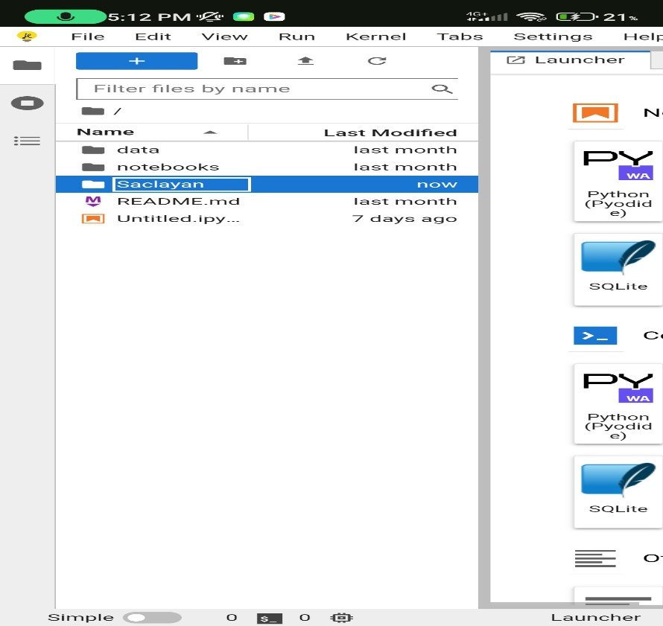

**TO WRITE CALL DICTIONARY METHOD**

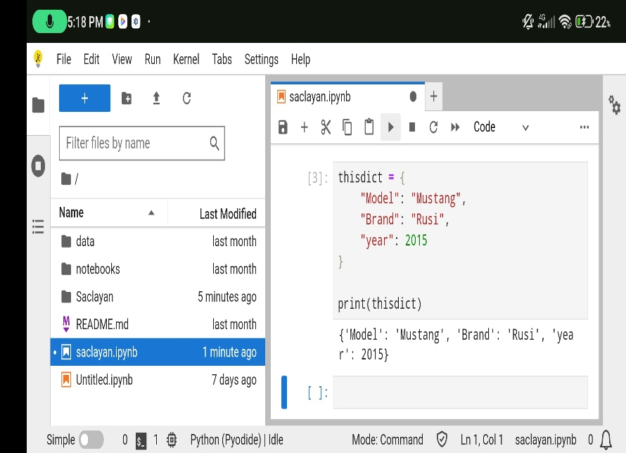

**ADDING TEXT FILE**

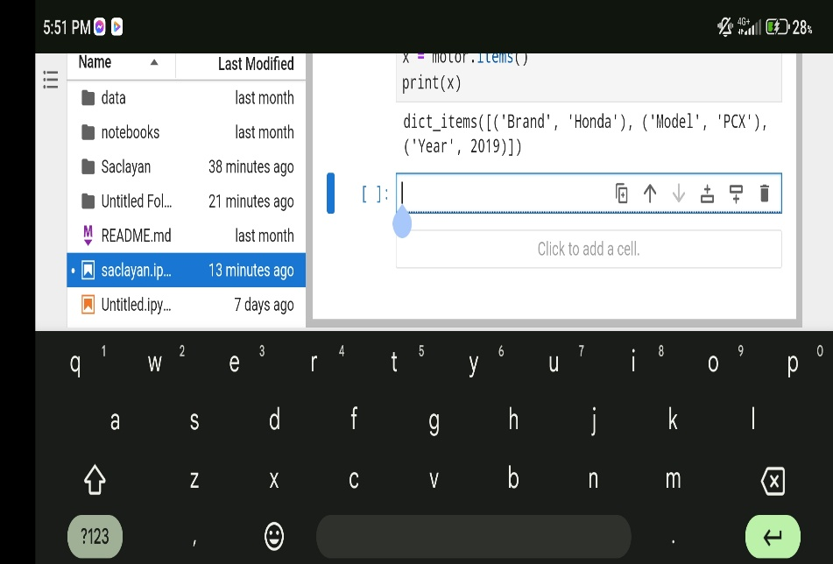

**CSV FILE FOR THE ANALYSIS AND VISUALIZATION**

**SACLAYAN, ROJAN R.**

**LASAP, ARDY**

**LIM, JEROME**

**JERYK**

**OKANDA, RYU**

**CS3C**

**GROUP 5**